Texas A&M AgriLife Extension





TEXAS PECAN PEST

MANAGEMENT NEWSLETTER

**June 20, 2017, No. 17-6**

**Bill Ree, Extension Program Specialist III – IPM**

**AgriLife Extension South Campus**

**1470 William D. Fitch Parkway, 2150 TAMU**

**College Station, TX 77843-2150**

**979-458-0335 – office**

[**w-ree@tamu.edu**](mailto:w-ree@tamu.edu)

**http://pecanipm.tamu.edu**

**\*\*\*\*\*\*\*\*\*\*\*\*\*\*\*\*\*\*\*\*\*\*\*\*\*\*\*\*\*\*\*\*\*\*\*\*\*\*\*\***

**TEXAS PECAN GROWERS ASSOCIATION**

**\*\*\*\*\*\*\*\*\*\*\*\*\*\*\*\*\*\*\*\*\*\*\*\*\*\*\*\*\*\*\*\*\*\*\*\*\*\*\*\***

**TEXAS PECAN GROWERS ASSOCIATION**

**4348 Carter Creek, Suite 101 Bryan, TX 77802**

**Ph: 979-846-3285; Fax: 979-846-1752**

[**pecans@tpga.org**](mailto:pecans@tpga.org) **,** [**www.tpga.org**](http://www.tpga.org)

**\*\*\*\*\*\*\*\*\*\*\*\*\*\*\*\*\*\*\*\*\*\*\*\*\*\*\*\*\*\*\*\*\*\*\*\*\*\*\*\***

**GENERAL**

From what I have seen and reports received the crop is all across the board. I have seen light crops, heavy crops, a light June drop and a heavy June drop. I think one of the most important threats at this time has to be pecan scab, especially in areas that receiving frequent showers.

**TPGA CONFERENCE**

During the upcoming TPGA Conference and Trade Show, July 9 – 11th, I will have a booth in the exhibit area (near registration desk) and invite everyone to come by and visit during the breaks. Also, I will be giving 1 hour CEU – IPM during Monday morning short course so bring your license so you can sign in if needed.

**2ND GENERATION PECANNUT CASEBEARER**

Second generation adults have been collected in pheromone traps since June 5th and eggs have been bound over the past 10 days or so. For those orchards with good to heavy crops (50% or more of terminals with clusters) I don’t see second generation PNC as a problem. However, for orchards with moderate to light crops second generation can be significant. In years where crop loads are light I strongly encourage producers to monitor activity with pheromone traps.

Although the prediction model is not set for the second generation, pheromone traps can be used to detect the onset of the adult flight. In addition to using pheromone traps I also open nutlets damaged by first generation larvae to check for pupae and stages of pupal maturity which lasts for an average of 9 days.

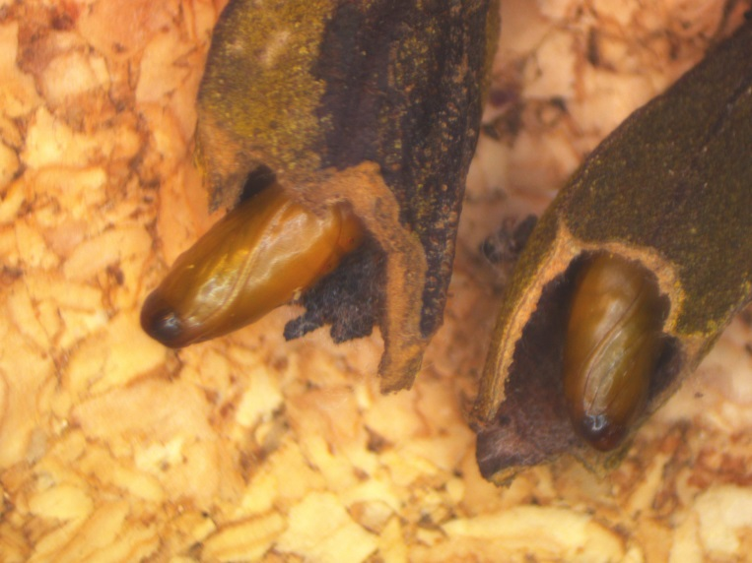

Figure 1. PNC pupae in damaged nutlets.

In consulting the Bible of PNC, “The Life History and Control of the Pecan Nut Casebearer”, Texas Agricultural Experiment Station, Bulletin No, 328, April 1926 by, S.W. Bilsing which provides detailed observations of PNC in the College Station area from 1918 - 1923: From this publication during the period from 1918 – 1923 for College Station, emergence of second generation adults started as early as June 5 (1918) and occurred as late as July 10 (1919). Over this six year period adult emergence was noted to range from 24 to 38 days. The early start of adult emergence in the Brazos/Burleson county area this year is a bit earlier than the 1926 report states for the College Station area.

Upon adult emergence egg lay will start in two to three days with eggs maturing in 4 or 5 days. Eggs are generally laid on the side of the nutlet near the stigma but some eggs I have found this month have been on the stigma, as shown in attached pictures, which has made them very hard to find. Upon emergence larvae will feed on the buds below the clusters and enter the bases of the nutlets.

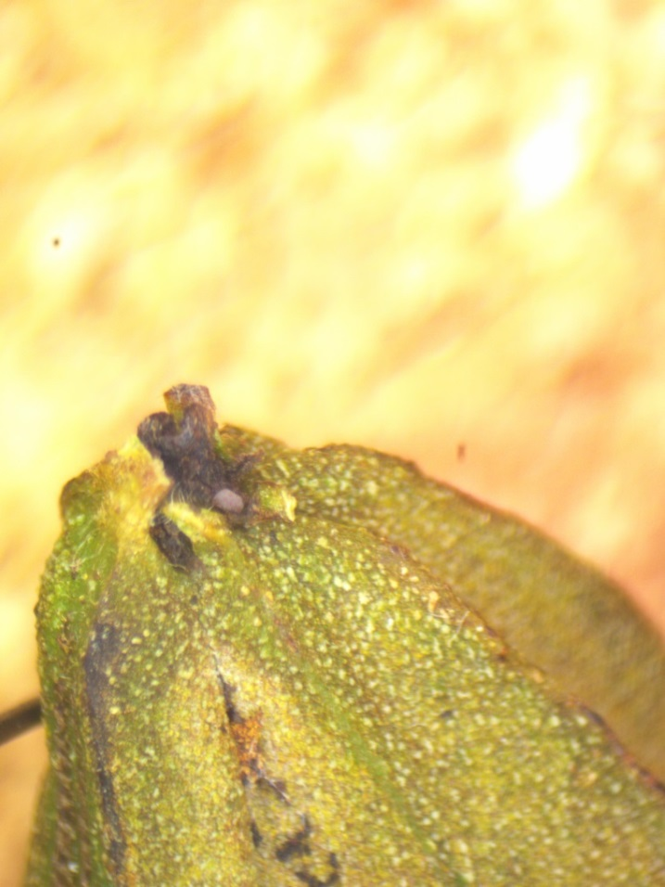

Figure 2. 2nd generation PNC egg on stigma (lobes removed)

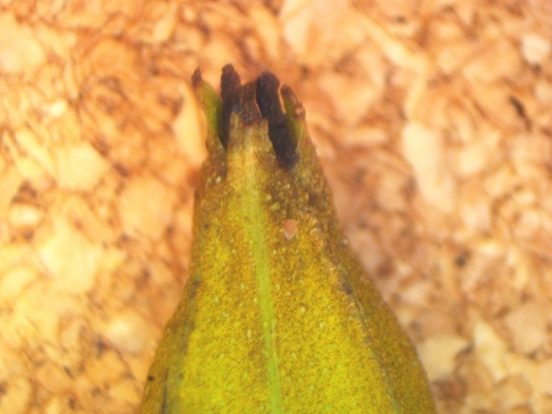

Figure 3. 2nd generation PNC egg on side of nut

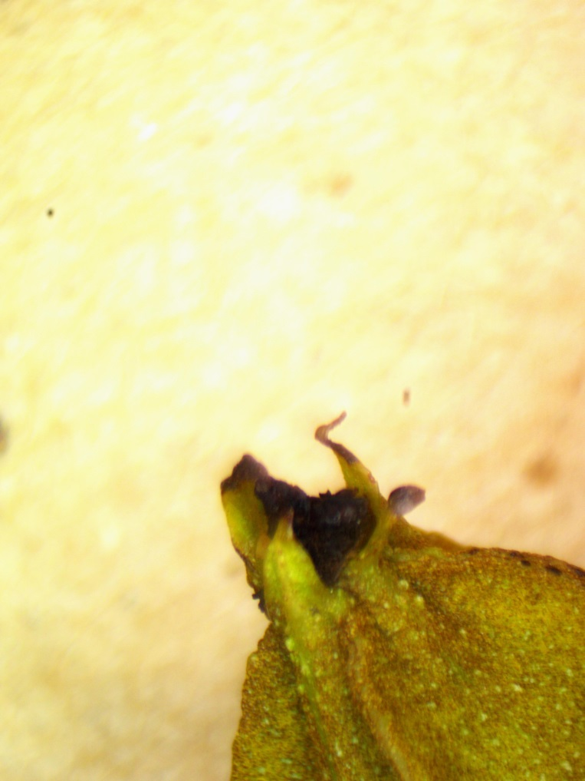

Figure 4. PNC egg on lobe next to stigma

For light crops, (30% of terminals with clusters) would be 1 percent infestation and use products that have an extended residual.

**2017 COUNTY/ STATE/REGIONAL MEETINGS/EVENTS**

**STATE/REGIONAL MEETINGS**

**June 22-23, 2017**

Tri-State Pecan Conference (LA, AR, MS)

Monroe, LA

Contact: Steve Norman @ 318-448-3139

[pecans@rosaliepecans.com](mailto:pecans@rosaliepecans.com)

**July 9-12, 2017**

**TPGA Annual Conference**

**Embassy Suites**

**Frisco, TX**

**Contact: TPGA @ 979-846-3285**

**August 25, 2017**

Arizona Pecan Growers Annual conference

Desert Diamond Casino and Hotel

Tucson, AZ

Contact: Mike Kilby

[mkilby@cals.arizona.edu](mailto:mkilby@cals.arizona.edu) or 520-403-4613

**\*\*\*\*\*\*\*\*\*\*\*\*\*\*\*\*\*\*\*\*\*\*\*\*\*\*\*\*\*\*\*\*\*\*\*\***

**The information given herein is for educational purposes only. References to commercial products or trade names are made with the understanding that no endorsement by the Texas A&M AgriLife Extension Service is implied.** **The members of Texas A&M AgriLife will provide equal opportunities in programs and activities, education, and employment to all persons regardless of race, color, sex, religion, national origin, age, disability, genetic information, veteran status, sexual orientation or gender identity and will strive to achieve full and equal employment opportunity throughout Texas A&M AgriLife. The Texas A&M University System, U.S. Department of Agriculture, and the County Commissioners Courts of Texas Cooperating**

**\*\*\*\*\*\*\*\*\*\*\*\*\*\*\*\*\*\*\*\*\*\*\*\*\*\*\*\*\*\*\*\*\*\*\*\*\***