Texas A&M AgriLife Extension





TEXAS PECAN PEST

MANAGEMENT NEWSLETTER

**May 31, 2017, No. 17-5**

**Bill Ree, Extension Program Specialist III – IPM**

**AgriLife Extension South Campus**

**1470 William D. Fitch Parkway, 2150 TAMU**

**College Station, TX 77843-2150**

**979-458-0335 – office**

[**w-ree@tamu.edu**](mailto:w-ree@tamu.edu)

**http://pecanipm.tamu.edu**

**\*\*\*\*\*\*\*\*\*\*\*\*\*\*\*\*\*\*\*\*\*\*\*\*\*\*\*\*\*\*\*\*\*\*\*\*\*\*\*\***

**TEXAS PECAN GROWERS ASSOCIATION**

**\*\*\*\*\*\*\*\*\*\*\*\*\*\*\*\*\*\*\*\*\*\*\*\*\*\*\*\*\*\*\*\*\*\*\*\*\*\*\*\***

**TEXAS PECAN GROWERS ASSOCIATION**

**4348 Carter Creek, Suite 101 Bryan, TX 77802**

**Ph: 979-846-3285; Fax: 979-846-1752**

[**pecans@tpga.org**](mailto:pecans@tpga.org) **,** [**www.tpga.org**](http://www.tpga.org)

**\*\*\*\*\*\*\*\*\*\*\*\*\*\*\*\*\*\*\*\*\*\*\*\*\*\*\*\*\*\*\*\*\*\*\*\*\*\*\*\***

**GENERAL**

I have had several producers ask what the crop looks like and I have heard the full range from light to looks really good. I’ll have to wait until after the June drop period before I can have a good idea.

**OBSCURE SCALE**, *Melanaspis obscura*

Obscure scale is a hard scale that attacks numerous hardwood trees such as oaks, pecan and other hickories, maple, hackberry and dogwood to name a few.

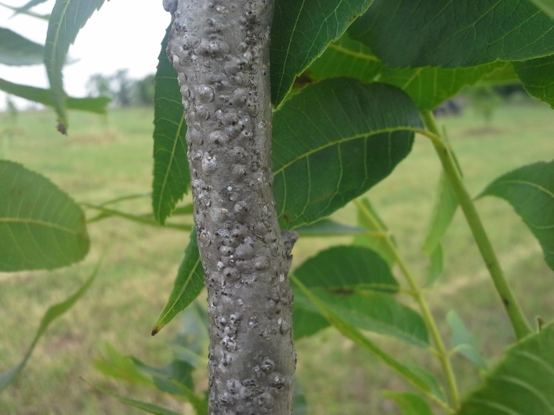

Figure . Pecan with heavy obscure scale

As the name implies, this scale insect is easy to over

look and if left unmanaged heavy infestations will reduce tree vigor and cause tree death.

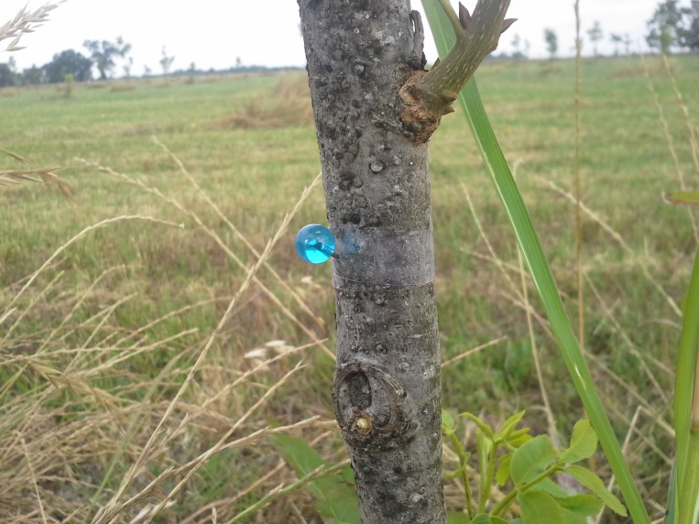

Figure . Monitoring for scale crawlers with double sided sticky tape. Tape secured to tree with push pin.

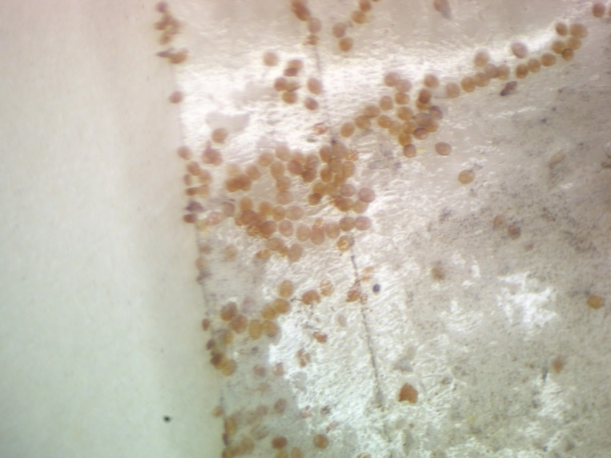

Figure . Obscure scale crawlers on sticky tape.

There are 4 species of parasites that attack this scale along with predatory mites and lady beetles that can help keep populations in check and if management is needed, this option is centered around late dormant season (February) applications of dormant oil. However, another option is a broad spectrum insecticide application that targets the crawler stage. One method of monitoring crawlers is with double sided sticky tape and here in the College Station area I have found crawler activity for the past couple weeks. An application of chlorpyrifos is going out this week in one orchard to suppress crawlers.

The following is some interesting reading on obscure scale I found in a 1929 TDA Bulletin on Growing Pecans.

TEXAS DEPARTMENT OF AGRICULTURE BULLETIN, No. 95, March 1929 “Growing Pecans in Texas”

By: J. E. Woodard, L.D. Romberg and F.J. Willmann

Obscure Scale, page 140…

“It seems that this scale is liable to become one of the worst pecan insects in Texas. Most of the pecan insects will come and go…..but this is not true of the obscure scale for if it once gets a start it will continue until it has killed the tree unless something is done to rid the tree of it. Two or three years are all that is required to kill an average sized tree and there are so many people that will not notice such a small insect as the obscure scale….”

Part of the text included results from a 1923 management trial that took 4 men 9 hours to put out 7 different treatments across 130 trees. The following is some conclusions of this trial.

“Two trees were sprayed with double strength lime sulphur. This did not injure the trees but it did very little good. Another tree was sprayed with pure kerosene and the tree never did show any sign of life when leafing out time came. Another tree was sprayed with pure crude oil. The scales were killed and the tree was slow about putting on foliage and died later in June. One tree was sprayed with oil drained from the crank case of automobiles, this tree never did show any sign of life.

Out of the seven different sprays used, some doing no good, some injuring the trees and some killing them, I would suggest that the only spray worthy of using is one pound of fish oil soap dissolved in one gallon of boiling water and one gallon of red engine oil was then added to this and thoroughly mixed. One-fourth pint of lye was added to seven gallons of water and then the soap and oil was added to this and thoroughly mixed and sprayed while hot”

**FALL WEBWORM**

Seem as if I am seeing more fall webworm than I have in several years, at least in the College Station area.

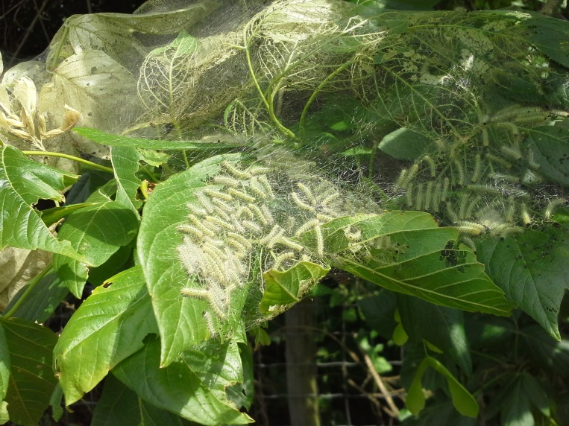

Figure . Fall webworm larvae

I see FWW more as an urban problem rather than a commercial production issue. I do feel that commercial applications of “caterpillar” specific products for pecan nut casebearer provide additional protection against FWW and first generation walnut caterpillar.

Management options for the homeowner include: 1) prune out webs/larvae if possible; 2) tear open webs to allow access for predators and 3) application of an insecticide.

**WALNUT CATERPILLAR**

The first generation walnut caterpillar is now reaching a stage where activity is becoming more visible.

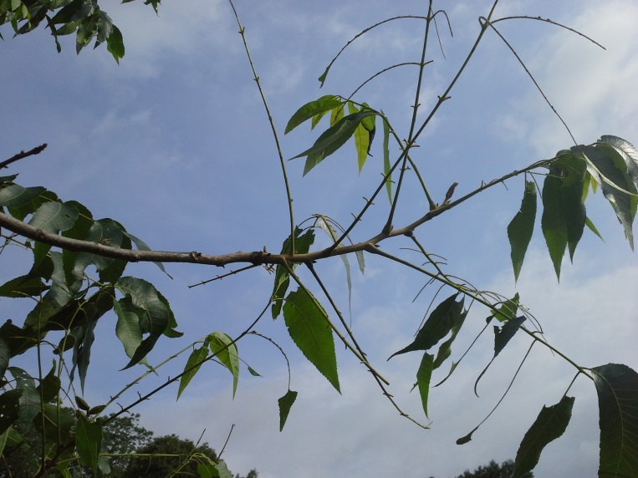

Figure . Walnut caterpillar damage

The best defense to prevent significant defoliation is to recognize activity before damage occurs. Defoliated branch terminals and cast skins on the trunk or a main scaffold limb are sure signs of activity.

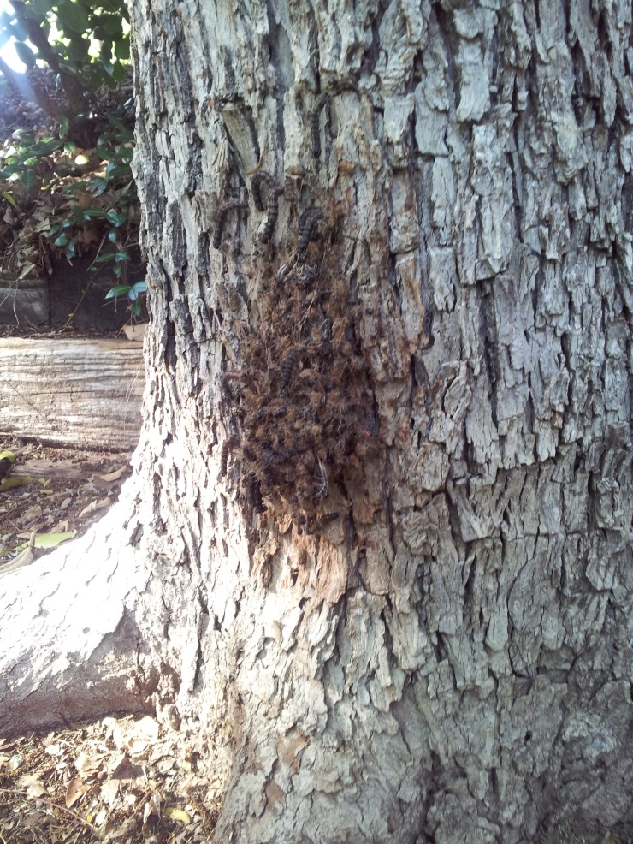

Figure 6. Cast skins of walnut caterpillar larvae molting from 4th to 5th instar.

One current hot spot that I am aware of at this time is in Fort Bend County, however, I have seen some activity in Burleson County and had one report of very light activity in DeWitt County. Management options can include the application of caterpillar specific or broad spectrum insecticides. As with fall webworm I do feel that the commercial products recommended for pecan nut casebearer also provide additional protection for WC.

If anyone observes walnut caterpillar activity in their county I would like to hear about it.

**2017 COUNTY/ STATE/REGIONAL MEETINGS/EVENTS**

**STATE/REGIONAL MEETINGS**

**June 1-3, 2017**

Oklahoma Pecan Growers Annual Conference

Ardmore, OK

Contact: Amanda Early @ 580-235-1875 or

Charles Rohla @ ctrohla@noble.org

**June 22-23, 2017**

Tri-State Pecan Conference (LA, AR, MS)

Contact: Steve Norman @ 318-448-3139

[pecans@rosaliepecans.com](mailto:pecans@rosaliepecans.com)

**July 9-12, 2017**

**TPGA Annual Conference**

**Embassy Suites**

**Frisco, TX**

**Contact: TPGA @ 979-846-3285**

**August 25, 2017**

Arizona Pecan Growers Annual conference

Desert Diamond Casino and Hotel

Tucson, AZ

Contact: Mike Kilby

[mkilby@cals.arizona.edu](mailto:mkilby@cals.arizona.edu) or 520-403-4613

**\*\*\*\*\*\*\*\*\*\*\*\*\*\*\*\*\*\*\*\*\*\*\*\*\*\*\*\*\*\*\*\*\*\*\*\***

**The information given herein is for educational purposes only. References to commercial products or trade names are made with the understanding that no endorsement by the Texas A&M AgriLife Extension Service is implied.** **The members of Texas A&M AgriLife will provide equal opportunities in programs and activities, education, and employment to all persons regardless of race, color, sex, religion, national origin, age, disability, genetic information, veteran status, sexual orientation or gender identity and will strive to achieve full and equal employment opportunity throughout Texas A&M AgriLife. The Texas A&M University System, U.S. Department of Agriculture, and the County Commissioners Courts of Texas Cooperating**

**\*\*\*\*\*\*\*\*\*\*\*\*\*\*\*\*\*\*\*\*\*\*\*\*\*\*\*\*\*\*\*\*\*\*\*\*\***